It says error: cant delete or update a parent row: a foreign key constraint fails

It can be solved by deleting the corresponding record on child table and then deleting the one in parent table

Command:

SET AUTOCOMMIT = false;

delete

From purchaseditem

where purchaseID = 115;

delete

From purchase

where purchaseID = 115;

Commit;

Screenshot:

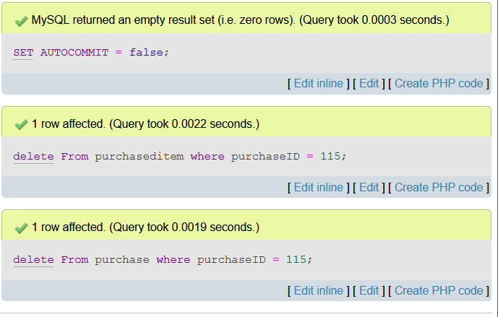

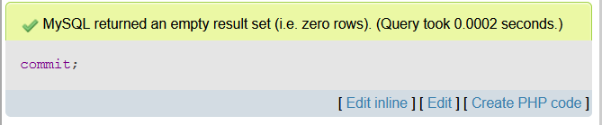

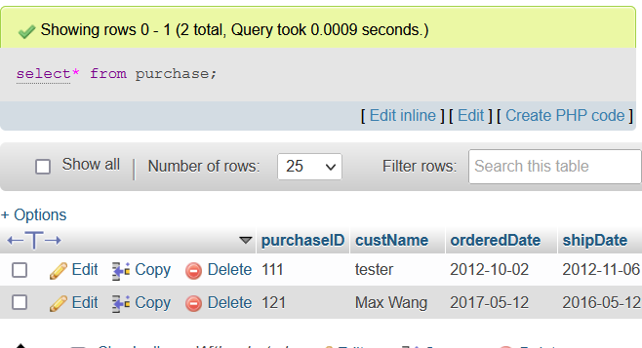

(the record for purchaseid 115 has been removed from the purchase table)